Lab-4 Report
K-Map for 3 variables

MIRIYALA PRANAY KAMAL
200030033

Aim: To design an optimal circuit for the given problem and implement them using the both 2 input logic gates and only NAND gates by using techniques of K-Map for 3 variables for simplifying the boolean expression.

Components used:

- IC 7404(NOT)
- IC 7408(AND)
- IC 7432(OR)
- IC 7400(NAND)
- Resistor array
- DIP switches
- LED displays
- Breadboard
- Power supply
- Multimeter

Design Procedure & Circuit diagram:

Problem Statements:

An industrial unit rings an emergency alarm based on the sensor output from the pressure and temperature units . In addition there is also a water level indicator which turns on this alarm. The alarm rings for the following conditions,

- If the water level is high when the other sensors are off.
- If the temperature sensor is active and the water level indicator is high . iii. Both pressure and temperature sensors are active.

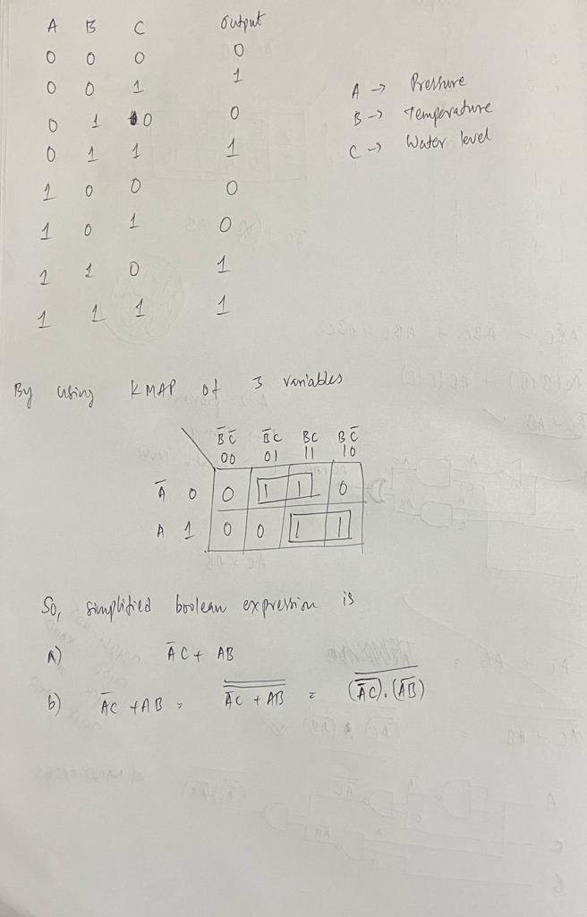

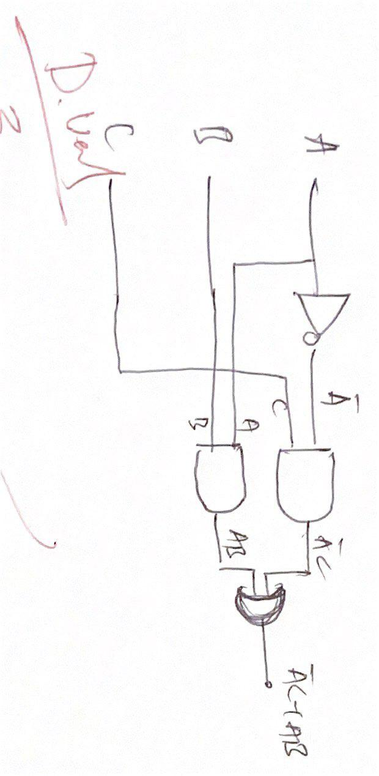

a. Design a digital circuit with basic gates( AND, OR, NOT) that controls the buzzer action for the above conditions.

Solution:



b. Repeat using a minimum number of 2 input NAND gates.

Solution:

Note: Choose pressure sensor output to be the MSB bit and water level indicator to be the LSB bit.

These Logic expressions gates can be implemented by using IC gates. The logic tables/Truth tables for these gates are:

AND GATE
INPUT 1 | INPUT 2 | OUTPUT
0 | 0 | 0
0 | 1 | 0
1 | 0 | 0
1 | 1 | 1

NOT GATE

INPUT | OUTPUT
0 | 1
1 | 0

NAND GATE

INPUT 1 | INPUT 2 | OUTPUT
0 | 0 | 1
0 | 1 | 1
1 | 0 | 1
1 | 1 | 0

OR GATE

INPUT 1 | INPUT 2 | OUTPUT
0 | 0 | 0
0 | 1 | 1
1 | 0 | 1
1 | 1 | 1

Circuit Snapshots:

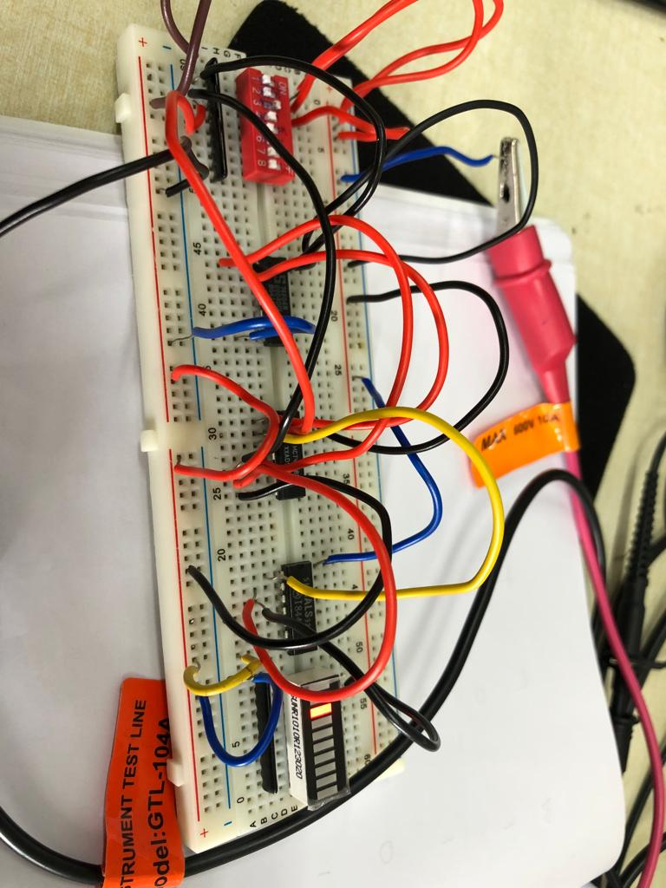
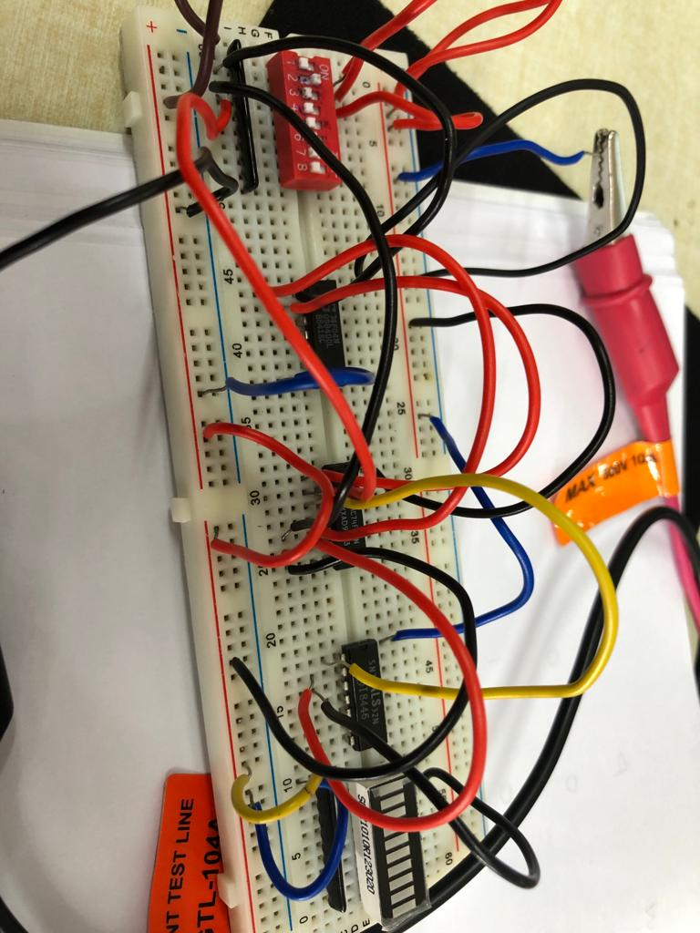
Design a digital circuit with basic gates( AND, OR, NOT) that controls the buzzer action for the above conditions.

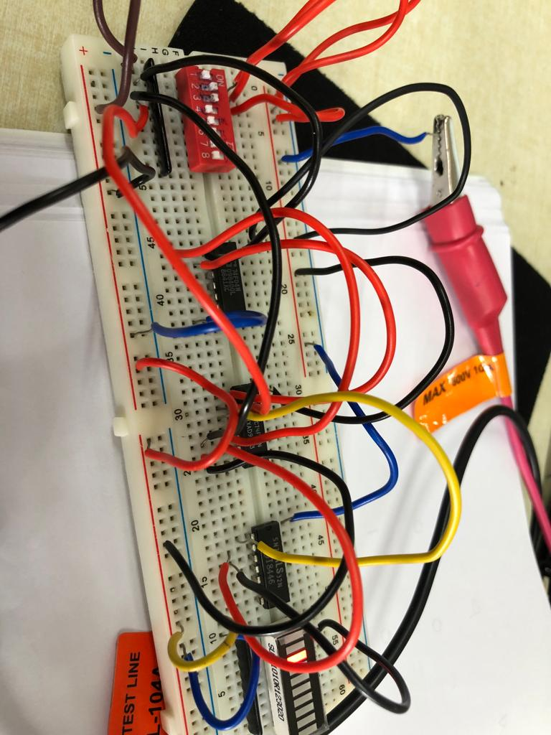
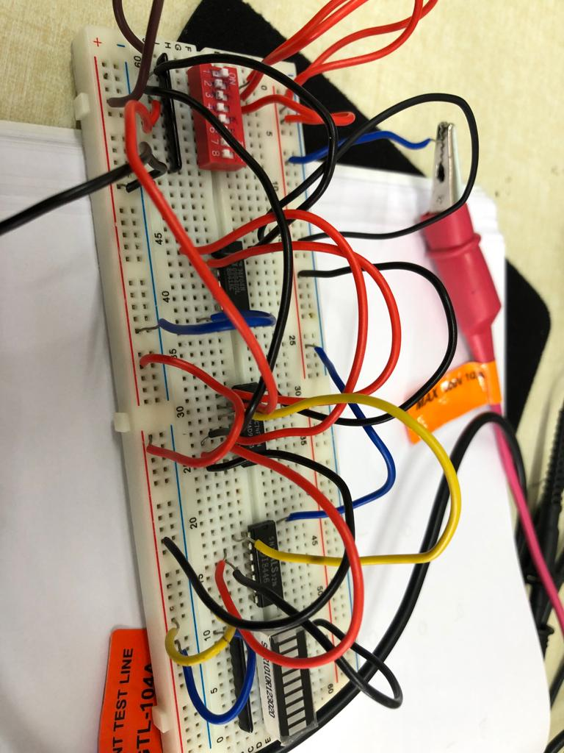

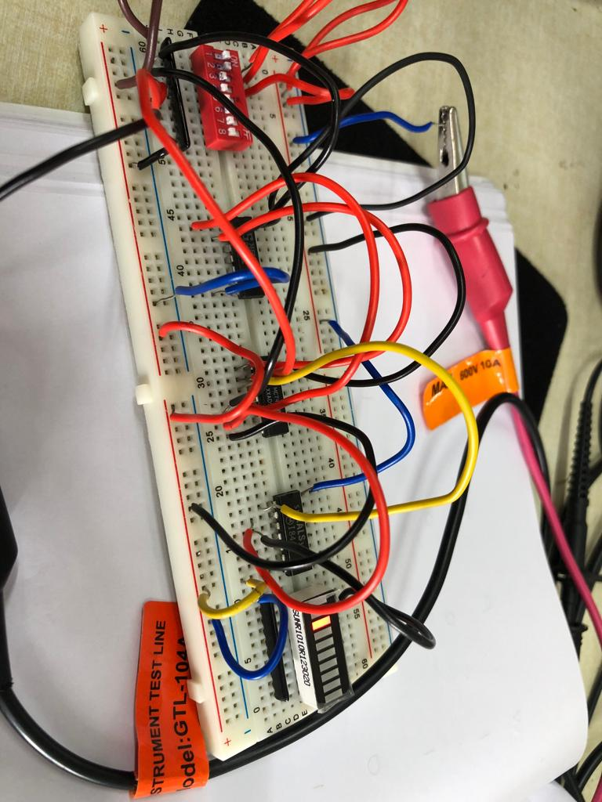
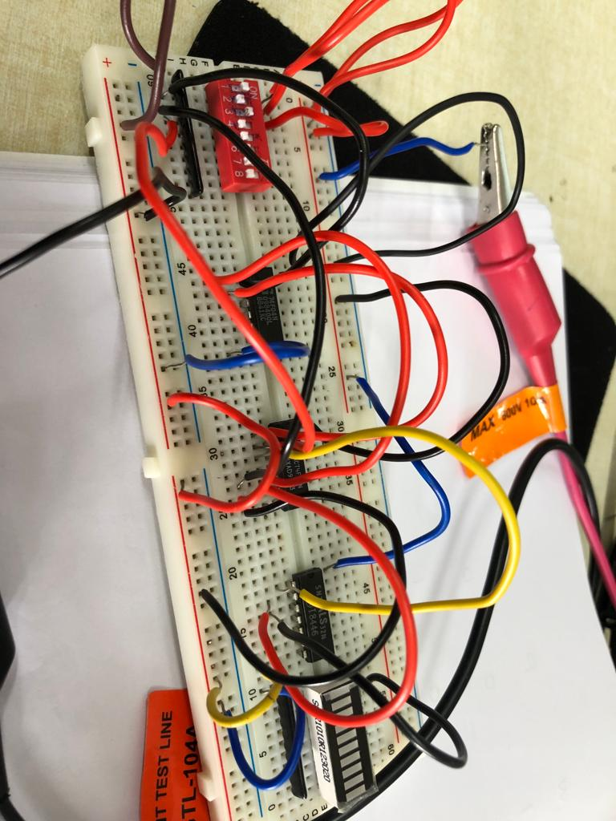

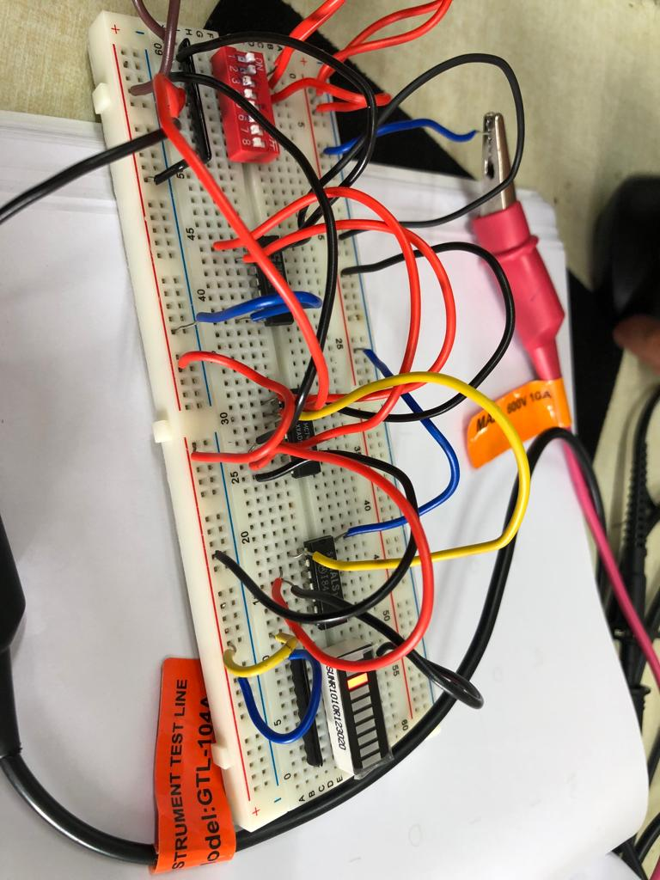
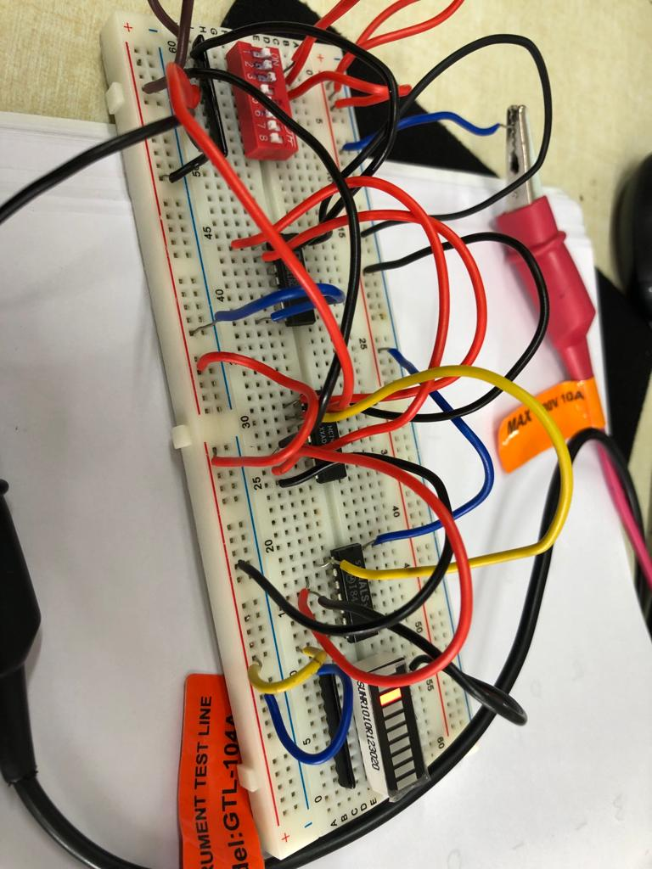

Repeat using a minimum number of 2 input NAND gates.

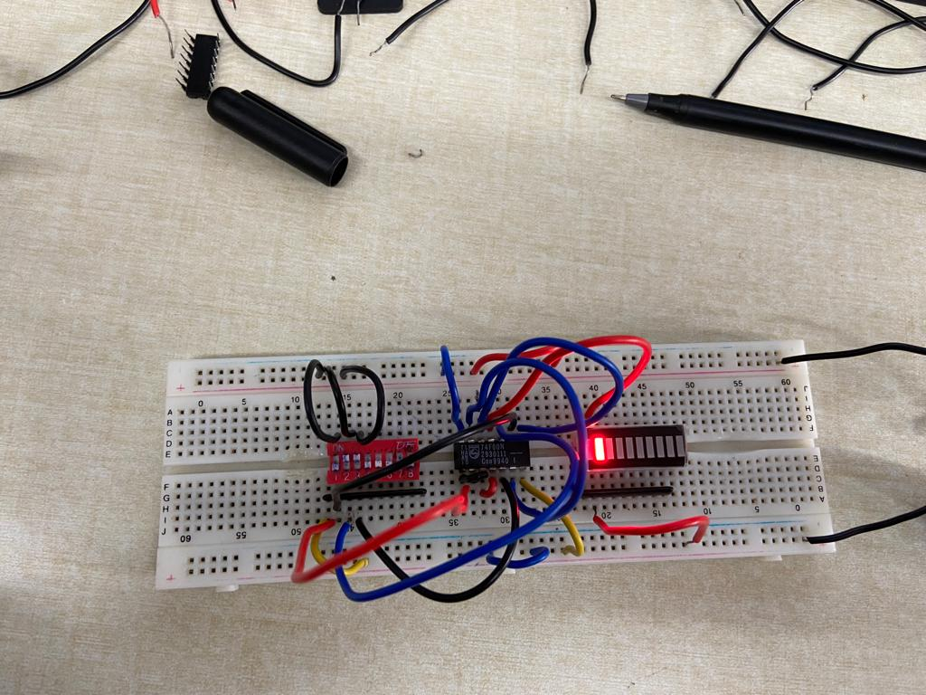
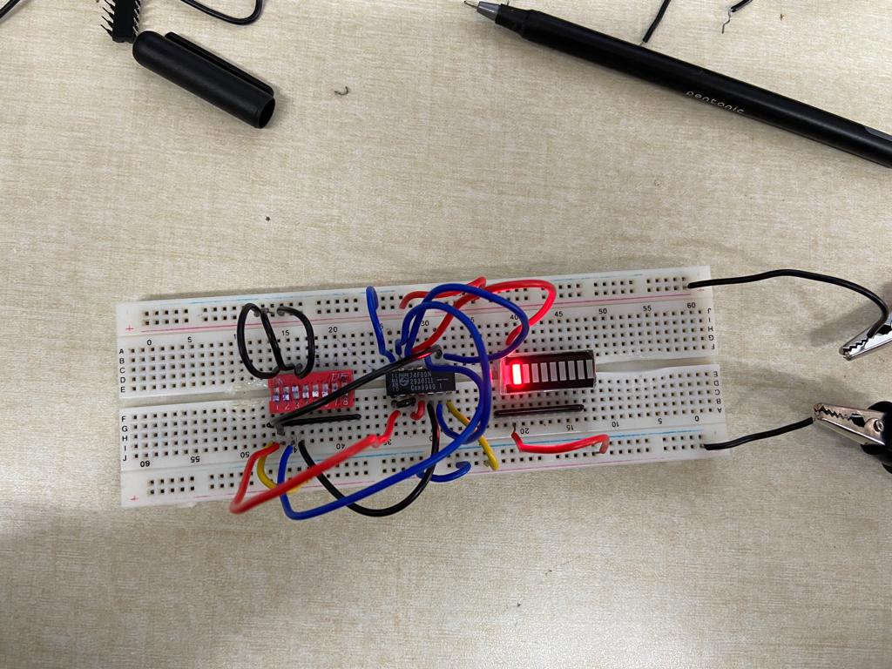

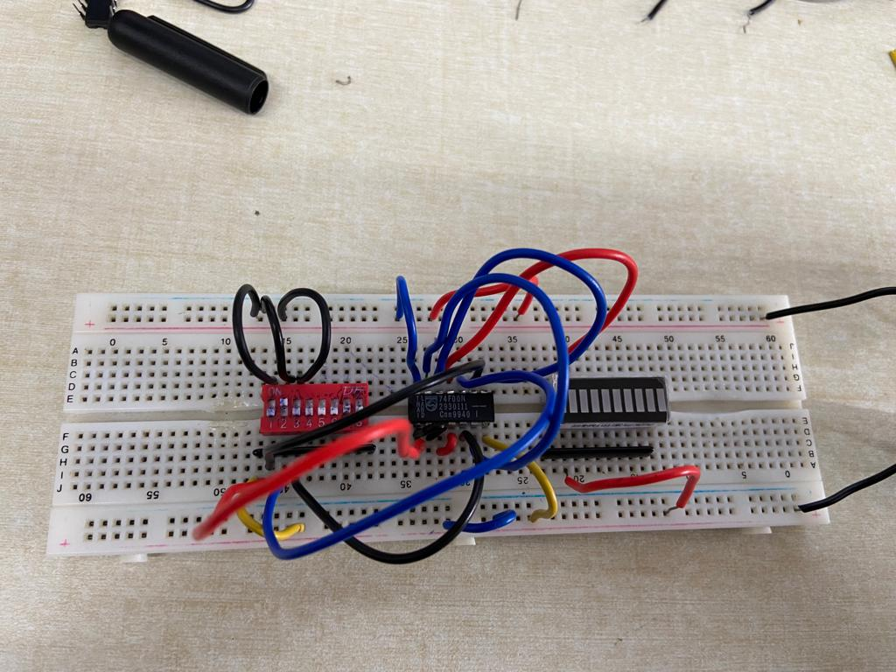
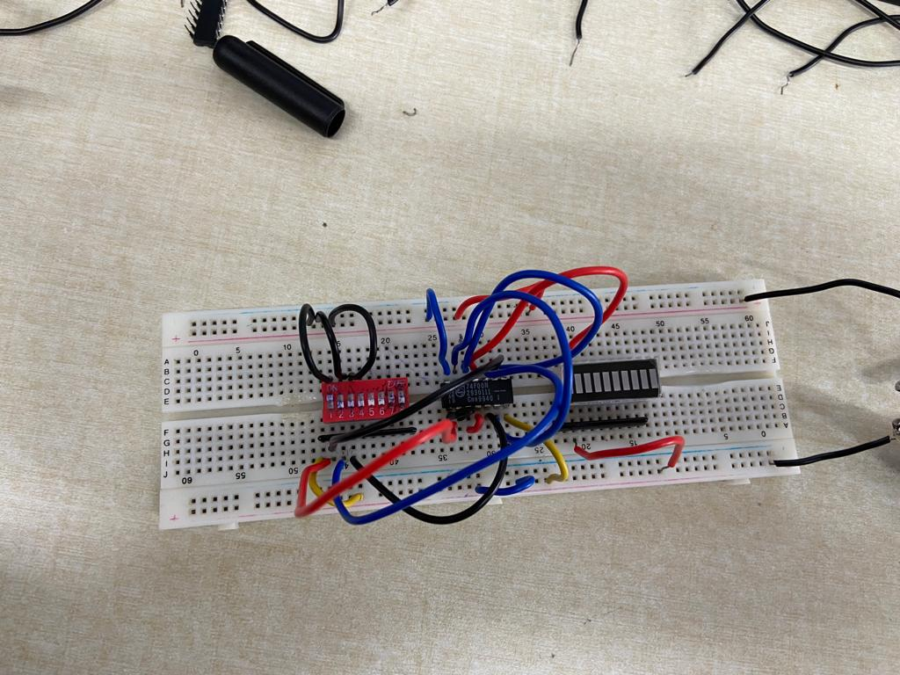

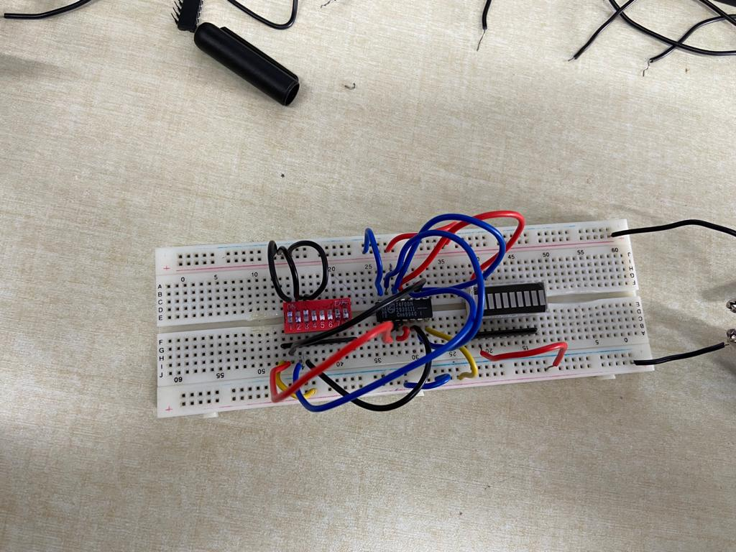
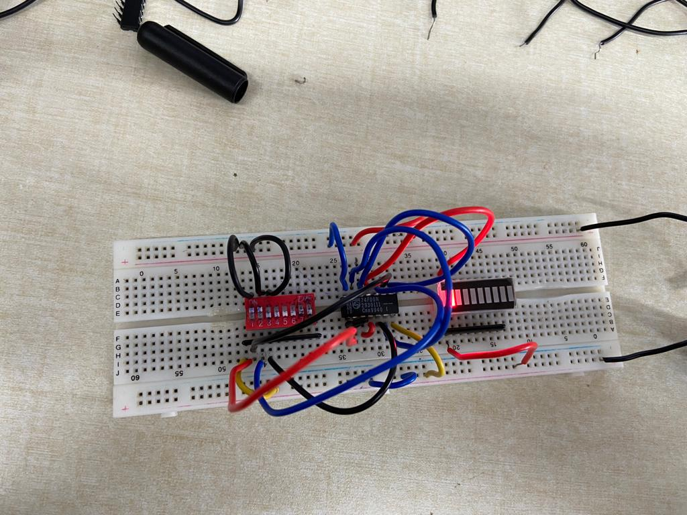

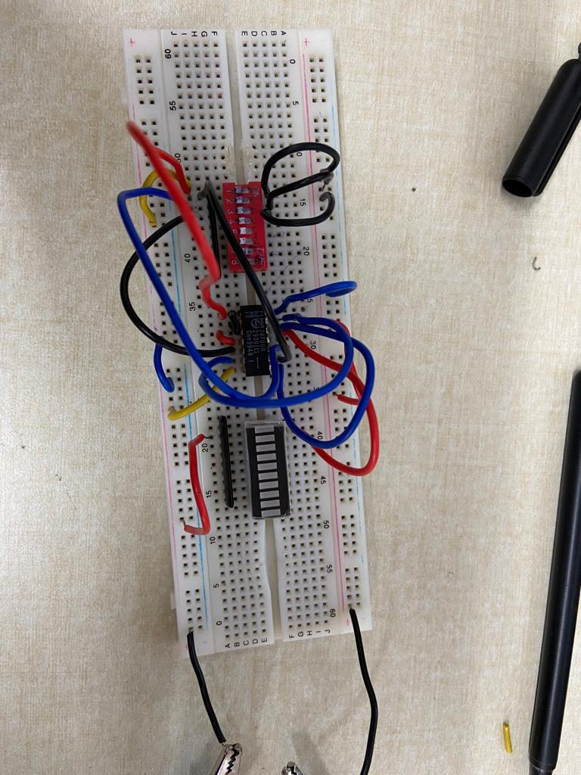

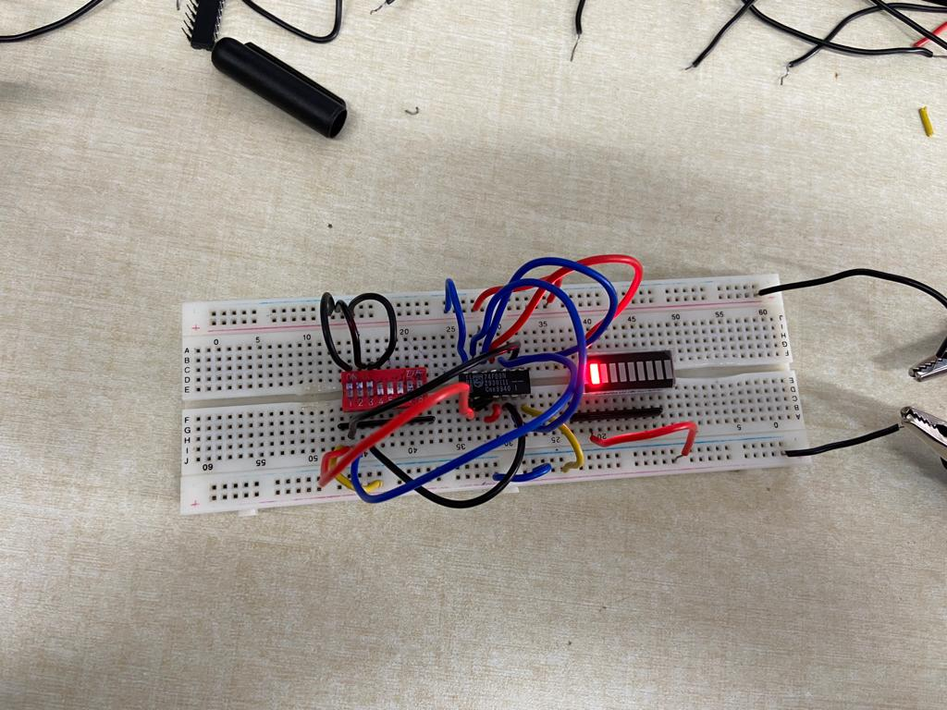

Results and Discussions:

The snapshots corresponding to each of the gates exactly represents the required logic logic hence we have implemented the solution using both 2 input basic logic gates and only NAND gates.

Conclusion:

We have designed the optimal circuit for the given problem and implemented it using the both 2 input logic gates and only NAND gates.

